Geometry
Unit 1 – Lesson 8

- Write a two-column proof showing that congruence of segments is symmetric.

Given:
Prove:

Statements | Reasons

In the table below, fill in the property of equality or congruence that justifies each statement.
Statement | Property
2. If , then .
3. If and , then .
4. If , then .
Using the diagram, solve the following problems.
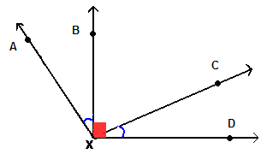
5. If $m∠\text{AXB}=\text{27}°$ and $m∠\text{BXC}=\text{83}°$, then find $m∠\text{AXC}$.
6. Find $m∠\text{BXC}$if $m∠\text{CXD}=\text{27}°$.
7. Name two pair of complementary angles.
8. If $m∠\text{AXB}=2x+8$and $m∠\text{CXD}=5x−\text{25}$, find x.
9. Find $m∠\text{BXC}$if $m∠\text{CXD}=\text{23}°$.
Use the diagram below to answer the following questions.
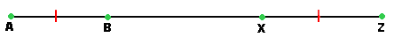
10. Name a segment congruent to $\overline{\text{AB}}$.
11. If AB = 2x + 4 and XZ = 26 find x.
12. If AB = 24 and AZ = 84, find BX.

Answer each question.
13. $∠A$ and $∠B$ form a linear pair. If $m∠A=\frac{1}{5}x+\text{30}$and $m∠B=\text{75}°$, find x.
14. $∠1$ and $∠2$ are complementary. $∠1$ and $∠4$ are congruent and $m∠3=\text{33}°\text{.}$ Find the measure of each numbered angle.
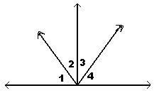
15. The measures of two supplementary angles are in the ratio of 5 to 1. What is the measure of each angle?

